1. Create ARM Template for deploy storage account
2. Create new project in Github and paste it in Github

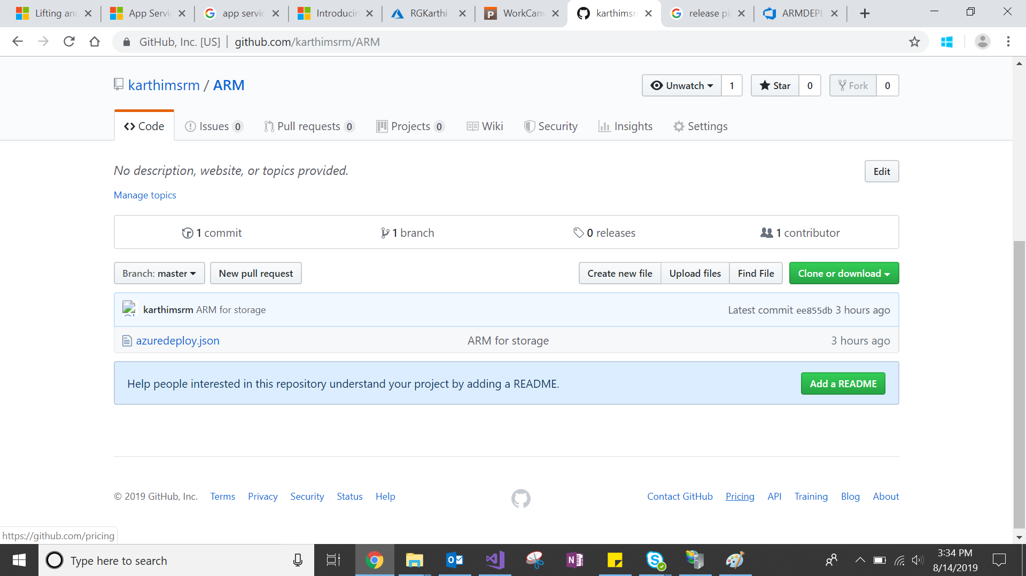

Copy the github link from Clone or download

1. Create new project and build pipeline as well
2. Under Build create 2 tasks as below screenshot

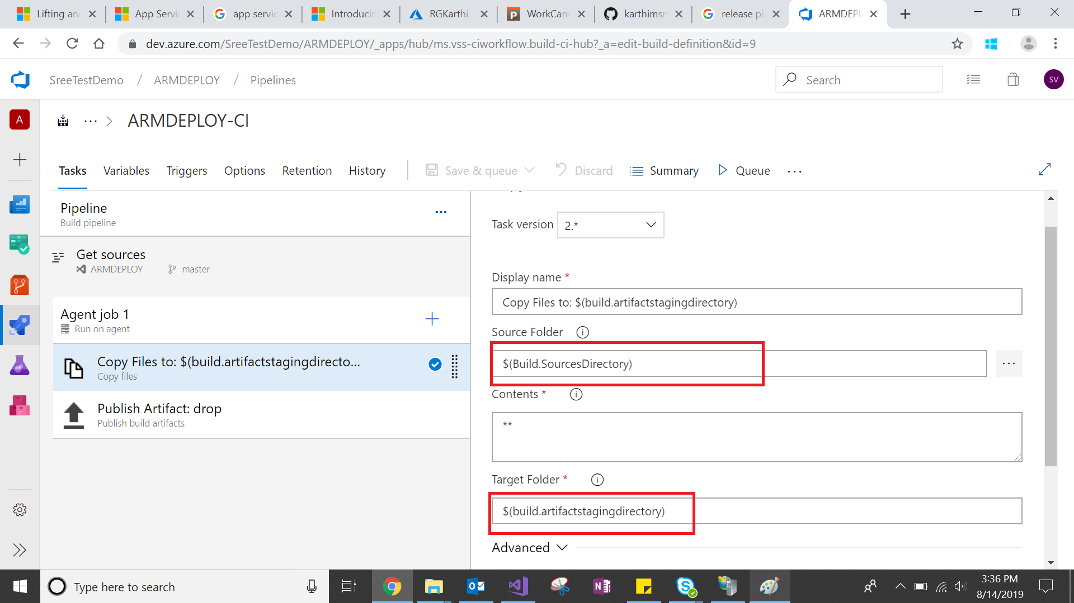

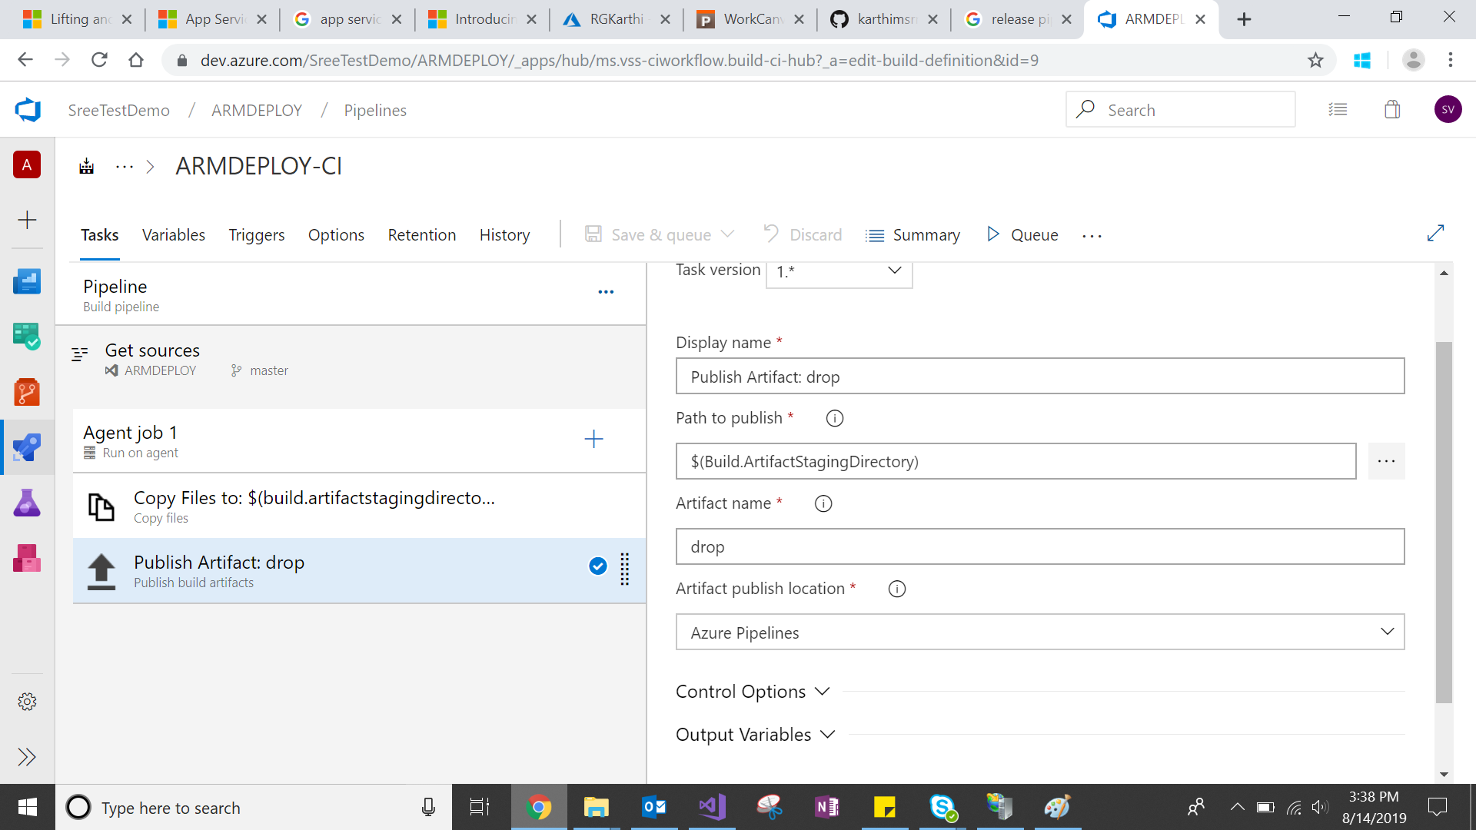

1. Click on save and queue
2. Create Release pipeline
3. Add Empty Job and choose the build artifact which created in build pipeline
4. Click on task

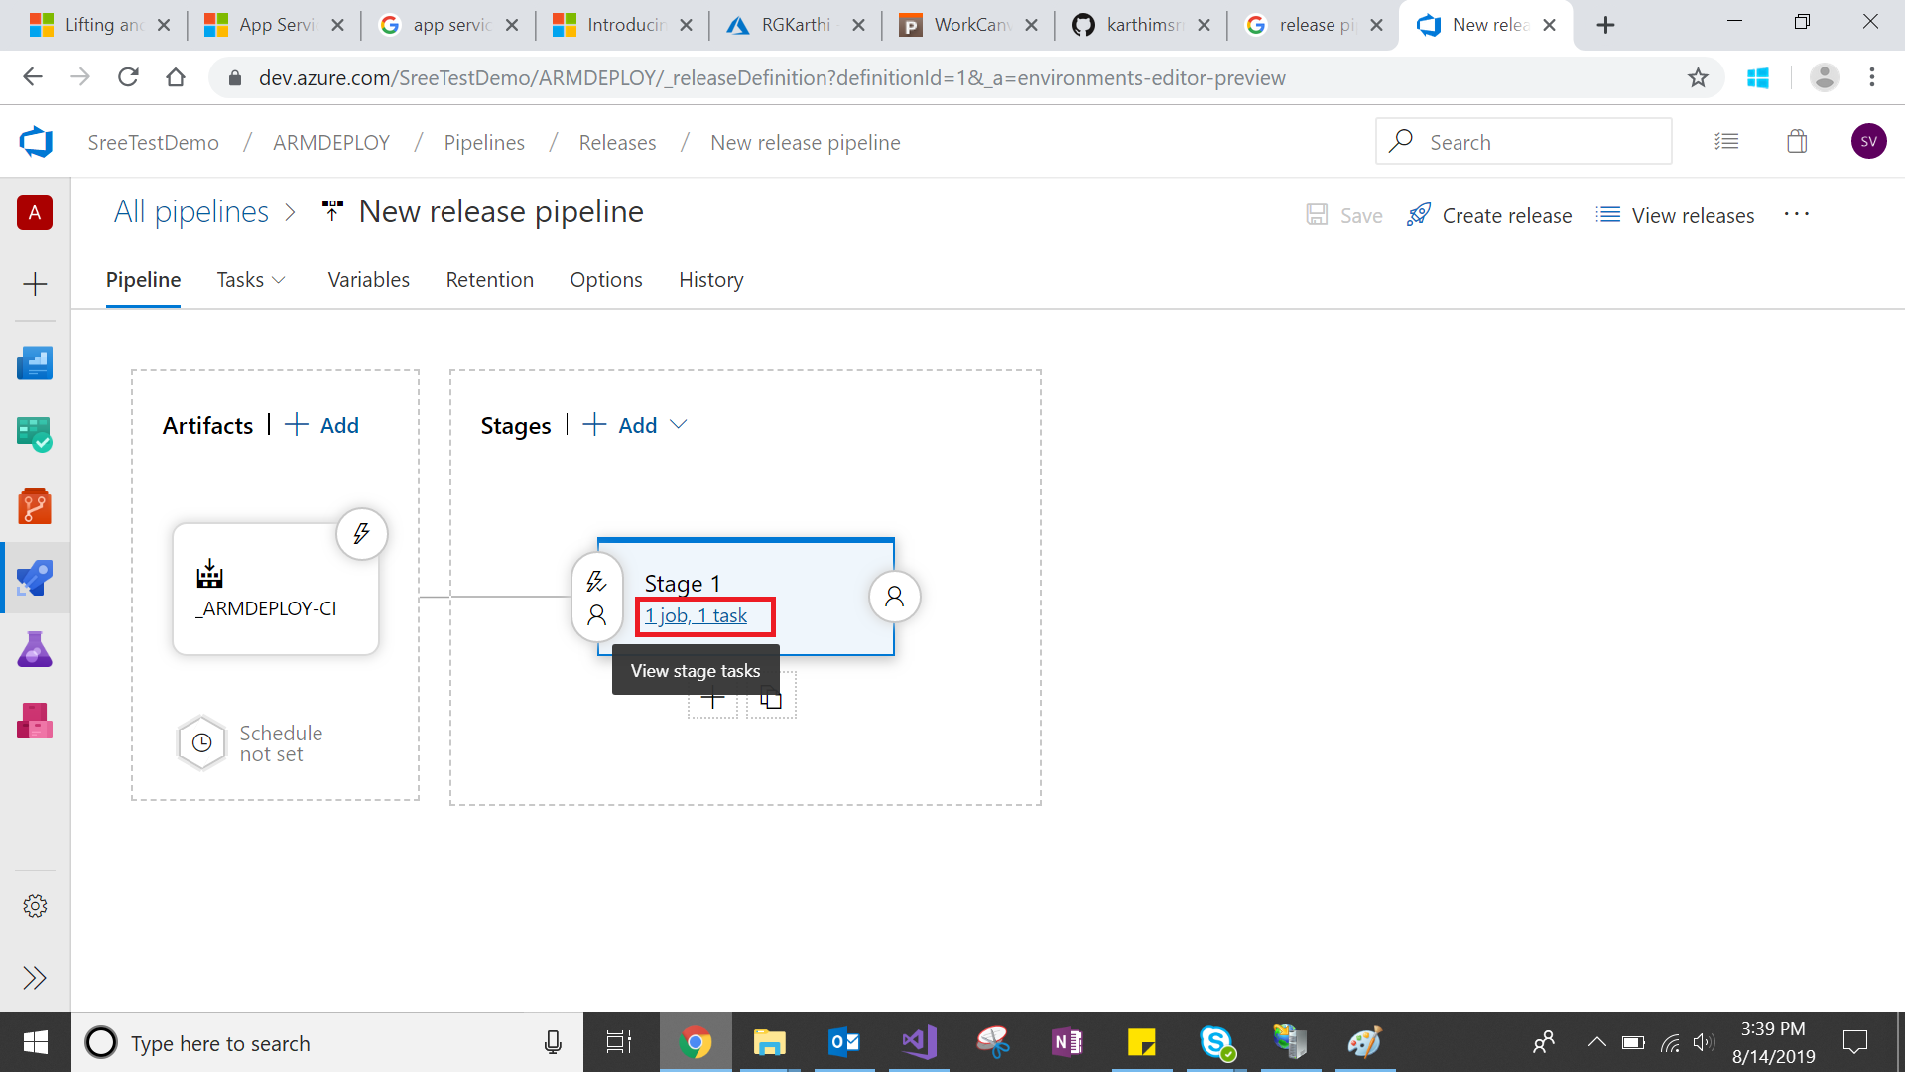

1. Select azure resource deployment group

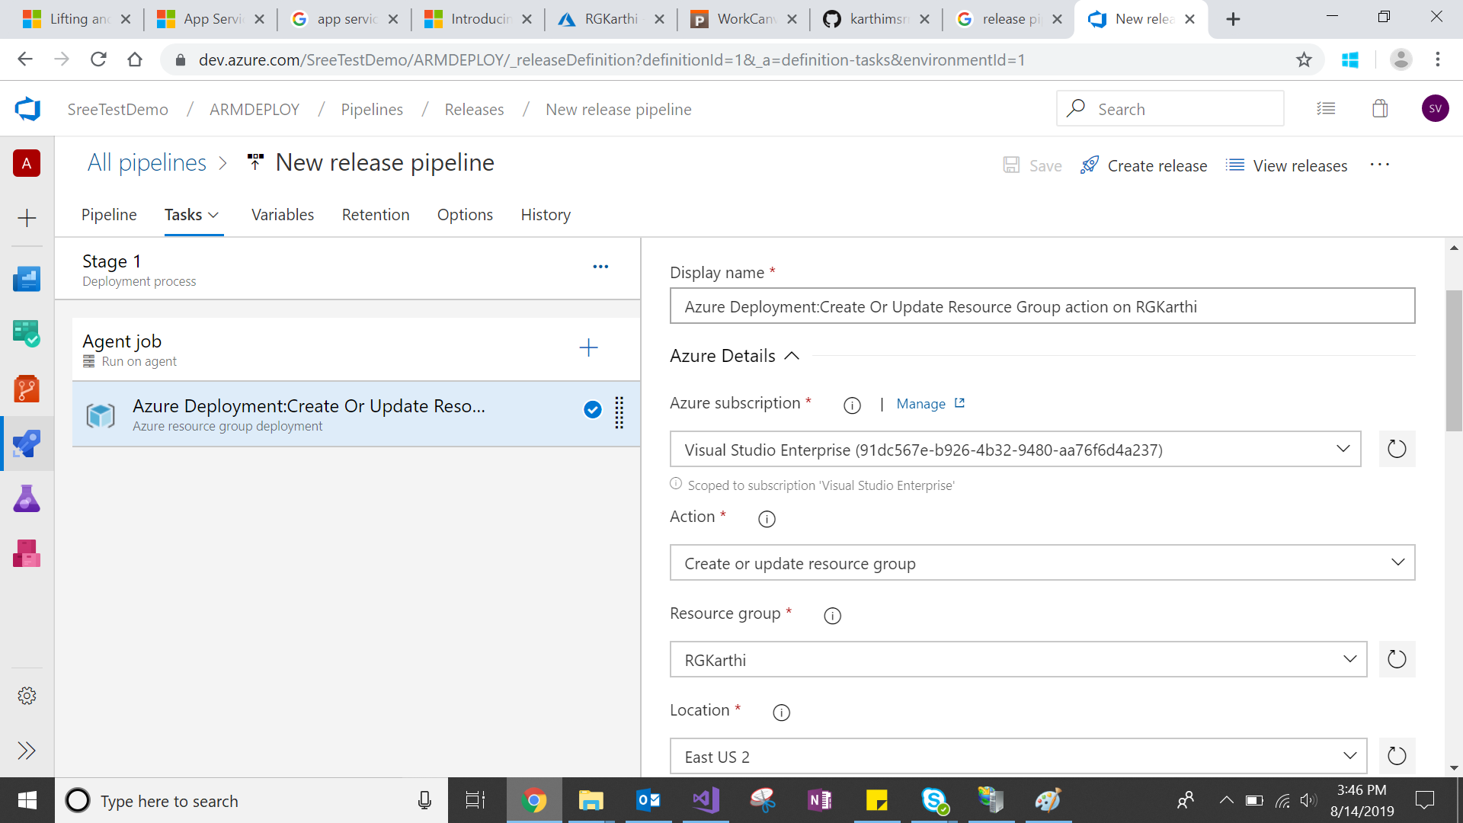

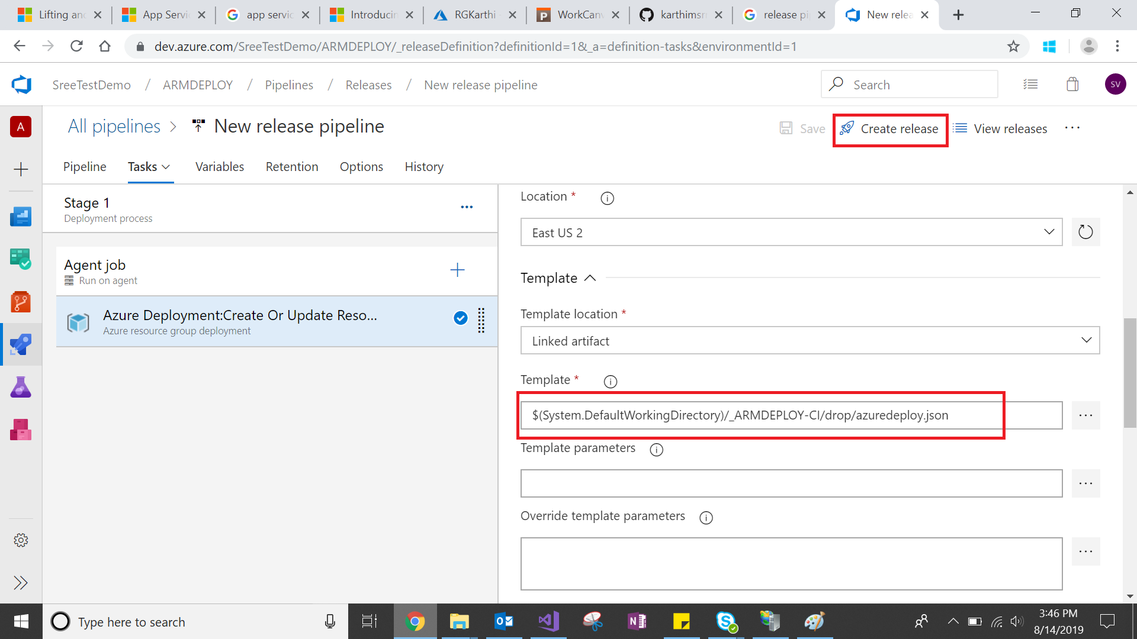

1. Click on Save and create release as well

